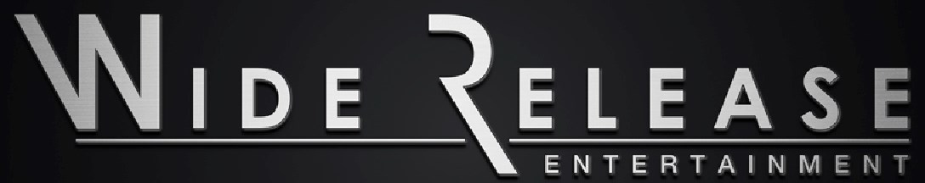

WR Entertainment ASA ("WR ASA") is a book-to-film entertainment company focused on acquiring excellent literary content and producing high quality motion pictures to mainstream audiences.

WR ASA is a publicly traded entity, based in Oslo, Norway, and owns 100% of the capital stock of WR Films Entertainment Group, Inc., ("WR Inc."), a California corporation located in Los Angeles (together, "the Company" or the "Group"), WR Inc. is the active operating and creative entity.

WR Inc. is an independent producer of feature-length motion pictures and publisher of electronic books ("eBooks"). In developing and acquiring intellectual properties for motion picture production, the Company also acquires rights for television, eBook and book publishing, music publishing, games, video games, toys, merchandising and licensing.

Management's primary focus is on the development and production of a motion picture series and the publication and sale of eBooks based on one of WRIS largest IP assets, the Morgan Kane book series, which has sold over 20 million copies in Europe alone, making it one of the top 100 best-selling book series in the world.

The Morgan Kane books were written by Louis Masterson

(born Kjell Hallbing, 1934-2004).

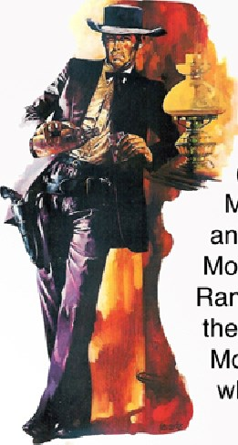Masterson wrote stories on the life and adventures of the character Morgan Kane, an outlaw, Texas Ranger, and later a U.S. Marshal in the Wild West. Masterson wrote 83 Morgan Kane books in total, of which 41 are translated into English.

# Financial Summary

The Company's revenue from sales of ebooks of Morgan Kane was NOK 53 889 for the six months ended June 30. Operating costs and expenses for 2017 totaled NOK 7.5 Million, including legal fees, accounting fees, Morgan Kane film development costs, salaries, travel and other expenses. Legal fees of NOK 3.7 Million were incurred during the period as a direct result of the costs of litigation, which is described later in this report. The Company's net loss for the six months ended June go, 2017 was NOK 7.6 Million.

As reported in the Company's 2016 Annual Reporti founders Gunnar Ryan Wiik and Jim Cardwell lead the WR ASA Board of Directors as Vice Chairman and Chairman, respectively, from January 2016 to December 2016. Both left in December 2016. Wiik resigned on December 12, 2016 after creative differences with the Company and Cardwell was removed as Chairman by a majority vote of the shareholders at an Extraordinary General Meeting (EGM) on December 14, 2016.

In January 201 7, WR ASA announced Frode Foss would be Chairman of the Board and Ulrik Knap was elected a Board Director by shareholders in an Extraordinary General Meeting.

In May 2017, Ulrik Knap resigned from WR ASA's Board of Directors and moved to the Advisory Board.

On June 22 at the WR ASA Annual General Meeting, Rolf Arne Høyen was elected to the Board of Directors.

Company Management: Erik Christoffersen serves as General Manager (Daglig Leder), Duane Eberlein as CFO and Tasmin Lucia-Khan as CEO and Board Director.

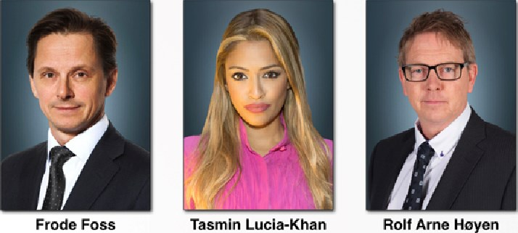

Chairman CEO, Board Director Board Director

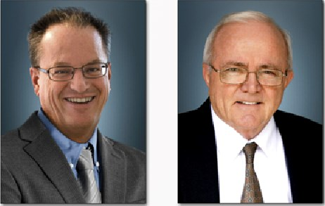

Erik Christoffersen Duane Eberlein

General Manager CFO

# January 2017

The producers of Morgan Kane continued the search for the lead actor in the title role, and continued to negotiate with the proposed director of Morgan Kane, as well as another Hollywood executive producer,

## February 2017

The Company announced that Hollywood writer Skip Woods, (X-Men Wolverine, Swordfish and the Die Hard franchise) had started re-writing the Morgan Kane script to get it ready for production and increase the intensity of the action scenes, bringing a modern and original vision to the familiar western genre

### March 2017

Final negotiations took place for key talent and the proposed director for the Morgan Kane motion picture. Terms and compensation for the development, preproduction and production services for the film were in closing stages. Final contracts were also being drawn up for the services of another executive producer to work on the development of the planned Morgan Kane franchise.

#### May 17, 2017

The Company learned of an attempt by former Board member Gunnar Ryan Wiik to violate WR's intellectual property rights through the hiring of a cinema, and inviting shareholders to see video footage that belongs to the Company. The Company opposed this showing and it was cancelled

# June 22, 2017

The Company held its Annual General Meeting of Shareholders in Oslo, Norway. All board proposals were approved by the shareholders by 95% or more of the shareholders present and able to vote at the meeting. The Board of Directors decided to take no remuneration for the 2016 year.

In spite of the additional workload presented by the various lawsuits, the Company's management and Board remain dedicated to business and working hard to ensure we protect our intellectual property rights, and work towards producing the first Morgan Kane motion picture.

## Operating Expenses

The Company's operating expenses include legal fees, accounting fees, Morgan Kane film development costs, salaries and wages, travel and other general and administrative expenses, These costs and expenses are required to prepare for the production of the first Morgan Kane motion picture but also to protect the Company from infringement of copy right, violation of our intellectual property, general harm to shareholder value and defending any baseless claims that waste Company time and resources,

## Legal Fees

Legal fees of NOK 3.7 Million were incurred as a result of lawsuits from former management Gunnar Ryan Wiik and James Cardwell. These costs are substantial, and will continue to increase as long as the lawsuits are active.

### Debt

Of the Company's NOK 6.3 Million in debt, approximately NOK 1.95 Million was deferred to June 30, 2018 and approximately NOK 3 Million is subject to the outcome of the Wiik lawsuits. In prior years, shareholder debt was

renegotiated and continuously moved forward into the future, to facilitate and aid the production of the first Morgan Kane movie, and to have satisfactory cash flow for operations.

### Material Agreements

During QI/Q2, the Company spent significant time to get to final negotiations with key Hollywood talent, keen to get the first Morgan Kane movie off the ground, These creatives were highly respected movie industry professionals who had created some of the most iconic action scenes in the last 20 years of cinema. These agreements needed to be signed in order for the Company to move forward to commence the production of its first Morgan Kane movie. The timing of the lawsuits from former management of the Company was damaging on many levels and affected the Company's ability to sign key talent. The negative media rhetoric and legal action from former employee Wiik against the Company and its officers and directors, also greatly affected the Company's ability to close those key material agreements — agreements which are affected by the public perception of the Company. Management was forced to spend time and effort to defend the Company's actions which were taken at all times to protect shareholder value, protect intellectual property and protect the Morgan Kane film brand.

### U.S. Lawsuit by WR Inc. against Gunnar Ryan Wiik and Sissel Wiik

After a shareholder email in November 2016 requesting the Board to look into transactions of Gunnar Ryan Wiik, the Company started an internal review which turned into an external investigation into potential fraud committed by Wiik, In January 2017, the Company continued with the investigation into Wiik's shareholdings and use of company funds. New counsel with securities expertise was hired in the US to lead the investigation.

In February 201 7, the fraud investigation into Wiik's shareholdings continued in both Norway and the United States.

In March 2017, the Company conducted further interviews with key personnel and shareholders in relation to the fraud investigation into Wiik and was ready to send a legal letter and engage with Wiik's attorney demanding that he return the nearly 19 million WR shares he transferred to himself without Company approval. The hope and intent of the letter was to avoid litigation and resolve the situation with minimal impact to the Company's resources. On May 12, 201 7, the Company published a stock release regarding the ongoing investigation of millions of shares that belong to the company that were transferred to Gunnar Ryan Wiik in 2013.

On or about June 7, 2017, Gunnar Ryan Wiik and his mother, Sissel Wiik, attempted to register liens against both WR ASA and WR Inc. in the United States based on the loans between themselves and WR Inc., claiming an 80% security interest in the Morgan Kane rights. Because the Company believes, based on its investigation, that neither the loans nor the security interest are valid, it took action beginning on June 30, 2017, to cancel those liens through the I-J R. UCC procedure.

On June 19, 2017, WR Inc. filed a complaint against Gunnar Ryan Wiik in the Superior Court of California, County of Los Angeles, based on the results of an extensive investigation by the Company and external counsel into the Company's share distributions and finances. The complaint details allegations of Wiik's exploitation of trust and control of the Company, which he abused to fraudulently take 18,774,525 shares of stock that belonged to the Company for his personal benefit, as well as fraudulently claim over NOK 1.57 Million from the Company that he was not owed.

### Norwegian Injunction Action by Company against Gunnar Ryan Wiik

On June 29, 2017, based on evidence provided to the Oslo County Court, the Court provided the Company with a preliminary injunction against Wiik, freezing the 18,774,525 shares and prohibiting him from selling, transferring, pledging or otherwise disposing of the shares until a legally binding outcome is reached in the California lawsuit filed by WR Inc. against Wiik

### U.S. Lawsuit by Wiik against Tasmin Lucia-Khan

On March 15, 2017, Wiik filed a lawsuit against the Company's CEO, Tasmin Lucia-Khan, claiming that he was defamed and defrauded, that his screen-test had been set up to make him fail and that he was under duress when he resigned. He also made charges against other Company employees. Wiik claims an unspecified amount of damages, As the claims concern alleged actions that the CEO took on behalf of the Company, the Company is indemnifying the CEO and defending her from Wiik's claims pursuant to the terms of her employment contract, as well as pursuant to its statutory indemnity obligations under California law. The Company believes that Wiik fs lawsuit is baseless and without merit. No fraud or defamation took place. Wiik did not pass the screen test as judged

by the evaluation committee led by the director and the producer. Lucia-Khan facilitated the screen test and made all efforts to aid Wiik's chances of getting the Morgan Kane role, but he failed anyway.

U.S. Lawsuit by Cardwell against WR Inc. and WR ASA On April 4, 2017, former Chairman Cardwell filed a lawsuit against WR ASA and WR Inc. His claims arise from contracts allegedly entered into by him and the Company between 2009 and 2016, that he alleges the Company breached. Cardwell's contract claim seeks damages of approximately USD$I plus stock options or alternatively USD$I ,752,000. Cardwell originally also sought restitution damages, but WR Inc. successfully challenged that claim in the U.S. courts, resulting in its dismissal on July 18, 2017. Cardwell then filed an amended complaint, seeking the original contract damages as well as alternative equitable relief totaling USD $1 , 752,000 should the court determine no contract exists. At present, only WR Inc. is participating in Cardwell's lawsuit. Cardwell has attempted to serve WR ASA, but the Company believes that the attempted service was invalid, and has filed a motion to quash service. The Company believes that the Cardwell lawsuit is without merit and that the claimed damages lack factual or legal basis.

# July 14, 2017

The Company successfully re-negotiated WR Inc's $400,000 loan of our long term debtors,

## August 17, 2017

The share price fell to its lowest level of NOK 0,25. In this same period, by August 18, 2017, the largest shareholder in the Company had sold all available stock, adding a large volume to the supply of WR shares.

## September 18, 2017

WR ASA had now over 400 shareholders, and th s number continues to grow steadily.

U.S. Lawsuit by Gunnar Ryan Wiik and Sissel Wiik against WR Inc.

On July 20, 2017, Gunnar Ryan Wiik and Sissel Wiik filed a counterclaim against WR Inc. in California, claiming fraud, breach of contract, nine years of back wages totaling over NOK 90 Million, and other claims without specified damages.

In the counterclaim, Gunnar Ryan Wiik seeks an acting fee and producing fee, in addition to over NOK 90 Million (USD $11,640,000) as claimed compensation for his time. WR Inc. contends it has not breached any contract with Wiik, does not owe him any compensation, and does not owe any fees as Wiik has not acted in or produced any WR Inc. production. Wiik also asserts that he signed his resignation letter and waiver of claims against all WR Group companies under duress, and as such, the waiver of claims should be unenforceable, and that the waiver is unenforceable on other grounds. WR Inc. disputes this and believes the waiver should be enforced. The Company notes that Wiik resigned voluntarily after failing his screen testi and denies all allegations of "duress."

In the counterclaim, Wiik alleges that WR Inc. defaulted on a promissory note due to him. Wiik seeks USD $171 ,047 USD, (approximately NOK 1.330.000) plus interest. The promissory note in question is also the subject of WR Inc.'s original pending lawsuit against Wiik. WR Inc. seeks to cancel the note because it asserts that Wiik obtained the note by fraud, and the money was spent on personal expenses rather than the company. WR Inc. denies it owes anything to Wiik.

In the counterclaim, both of the Wiiks also assert that WR Inc. fraudulently conveyed the Morgan Kane film rights to its parent, WR ASA, without also conveying her security interest in those rights. In addition, Sissel Wiik asserts damages of USD $21 6,885, (approximately NOK 1.690.000) plus interest, against WR Inc. for defaulting on her promissory note. WR Inc. denies that it owes either Wiik or Sissel Wiik the claimed amounts. The Company further notes that the decision to transfer the Morgan Kane rights to WR ASA was done in conjunction with the public listing and private placement and was approved by management including Wiik himself.

The Company strongly denies all claims of fraud, as well as all the allegations made by both Wiiks in the counterclaim.

On August 24, 2017, WR Inc. responded to Gunnar Ryan Wiik and Sissel Wiik's claims and filed a crosscomplaint against Sissel Wiik disputing her claim that WR Inc. owes her a debt of $216,885 (approximately NOK 1.690.000) plus accrued interest, WR Inc.'s position is that the loan in question was disguised as a corporate loan but in fact spent on personal expenses. It is the Company's belief that Wiik committed multiple acts of fraud and breached fiduciary duties he owed to WR Inc. in creating the loan documents purporting to grant this debt to his mother, Sissel Wiik.

## Norwegian Court Injunction Action by Company against Gunnar Ryan Wiik

On August 1, 2017, Wiik filed a request with the Norwegian Courti asking for an order that WR ASA pay NOK 12.500.000 as appropriate security for the injunction that has frozen Wiik's 18.7 Million shares. Wiik asked that the Norwegian Court cancel the injunction if WR fails to pay this collateral. In response, the Company provided evidence to the Norwegian Court showing collateral should not be granted to Wiik. The Court then decided that the issue of security would be decided at an oral hearing.

On August 24 and 25, 2017 i the Norwegian court heard

evidence from the Company's CEO and Chairman, several WR Inc. employees, co-founders and WR ASA shareholders after Gunnar Ryan Wiik challenged the Norwegian court order granted on June 29, 2017 and requested an oral hearing. Wiik also presented evidence from himself and others, including former Chairman James Cardwell.

On September 5, 2017, after hearing the evidence, the Norwegian court rejected Wiik's arguments, finding his explanation as to how he acquired the 18,774,525 shares unconvincing and determined that his testimony appeared incomplete despite repeated direct questions from WR's lawyer. In the court's opinion, all documentary evidence supported WR Inc.'s claim that the shares were meant to belong to WR Inc., not Wiik, and that those documents corresponded with the testimony of Company's witnesses. As a result, the Norwegian Court not only upheld the injunction freezing the shares, but also ordered that Wiik pay WR Inc.'s attorneys' fees and other costs totaling NOK 549.801.

On September 6, 2017, Wiik announced to the press that he would appeal the decision made by the Norwegian Court to keep the injunction in place on the 18,774,525 shares, but has not yet done so.

U.S. Lawsuit by Wiik against Tasmin Lucia-Khan On September 27, 2017, the CEO Lucia-Khan filed an anti-SLAPP motion against Gunnar Ryan Wiik. A "Strategic Lawsuit Against Public Participation (SLAPP) is a lawsuit that is intended to censor, intimidate, and silence critics by burdening them with the cost of a legal defense until they abandon their criticism or opposition." The typical SLAPP plaintiff, Wiik, does not normally expect to win the lawsuit, The plaintiffs goals are accomplished if the defendant (Lucia-Khan) succumbs to 'fear, intimidation, mounting legal costs, or simple exhaustion and abandons the criticism of plaintiff," The anti-SLAPP motion was filed specifically as to Wiik's defamation claims, which generally accuse Lucia-Khan of defaming Wiik by discussing allegations of misconduct against him, including fraud, conversion, and breach of fiduciary duty.

The Company's CEO is filing this motion as both the Company and the CEO are of the belief that Wiik's lawsuit against her is both malicious and frivolous, and was designed to intimidate and humiliate the CEO and impede the fraud investigation against Wiik.

U.S. Lawsuit by Cardwell against WR Inc. and WR ASA On July 18, 2017, the U.S. court struck Cardwell's restitution claim in response to a motion filed by WR, Inc. Cardwell then filed an amended complaint, seeking the original contract damages as well as alternative equitable relief totaling USD $1 , 752,000 should the court determine no contract exists,

On July 28, 2017, WR ASA filed a motion to quash service. That motion is set to be heard October 23,

2017.

## Limited Operating History

The Company has a limited operating history and an investment in its shares involves significant risk, The Company's business has generated limited revenue during its initial years of development and growth, and can be considered subject to risks associated with development-level businesses, including the possibility that its business plan may not be successful.

### Development of Motion Picture Performance

The economic performance of any of the motion pictures produced by the Company cannot be assured, because the revenue derived from the production of a motion picture (which does not necessarily bear any correlation to the production or distribution costs incurred) depends primarily upon its acceptance by the public, which cannot be accurately predicted. The economic performance of a motion picture also depends upon the public' acceptance of competing films, the availability of alternative forms of entertainment and leisure time activities, general economic conditions and other tangible and intangible factors, all of which can change and cannot be predicted with certainty. Revenues generated by the Company's films are therefore highly uncertain and there can be no assurance that the Company's income will be

sufficient to meet its operating expenses and debt obligations.

## Outcome of Pending Lawsuits

The Company believes that Wiik's and Cardwell's lawsuits are without merit, and are vigorously defending against both suits, The Company likewise believes that the counterclaims filed by Wiik and Sissel Wiik in the fraud lawsuit are without merit, and are defending the same. Based on the current stage of the proceedings in the cases, the outcome of the legal proceedings, including the anticipated legal defense costs, remains uncertain; however, the Company may incur significant legal fees, settlements or damage awards. If any of these matters are not resolved favorably, losses arising from the results of litigation or settlements, as well as ongoing defense costs, could have a material adverse effect on the Company's business, financial condition, results of operations and cash flows. In addition, the affirmative lawsuit by WR Inc. against Wiik may also involve significant legal costs.

Commencement of Production of the First Movie The ability for the Company to conclude agreements with key talent is dependent on the public perception of the Company, which is currently affected by the ongoing lawsuits, The Company is reliant on signing key talent at the highest levels, but the negative attacks via legal action and through the media give rise to the risk that key talent will not sign up to the first movie due to the fear of reputation damage to themselves by association to the lawsuits from former management, While the Company believes the lawsuits received from former management are baseless and without meriti the Company still needs to vigorously defend its actions and fight the multiple allegations in order to protection the reputation and integrity of the Company, and protect shareholder value. There is risk that the ongoing lawsuits can damage the company's financial healthy the value of the Company's intellectual property, the Morgan Kane film brand, and the reputation of the Company's officers and directors - which in turn affect the ability for the Company to sign key talent to commence production on the first movie.

## Foreign Exchange Risk

The group operates internationally and is exposed to currency risk in several currencies, WR Inc. is a U.S. company operating and reporting transactions in USD. WR ASA is a Norwegian company operating and reporting transactions in NOK. For trade and transactions made in foreign currencies, a conversion risk arises. There are no guarantees that the operating results and financial position of both companies will not be affected by future changes in exchange rates.

### Working Environment and Gender Equality

The Group aims to be a workplace with equal opportunities in all areas, The Group's work environment is considered to be good. The Group has not implemented actions that affect the working environment. There were no injuries or accidents in the Group during the six months ended June 30, 2017, and there were no sick leave payments made nor any absences due to illness.

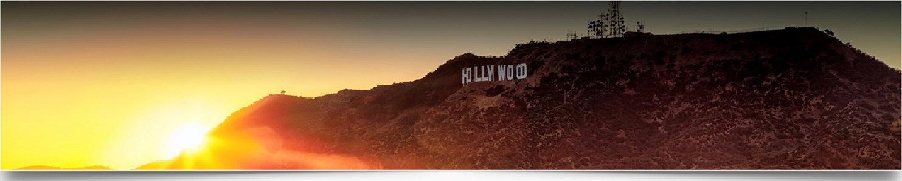The Board of Directors consists of two men and one woman. Of the Group's total of five employees, four are men and one is a woman. It has not been necessary to take any specific actions to promote equality or prevent discrimination between genders.

### Environment

The Company only applies work effort and capital to its operations, which has an insignificant effect on the environment. The Company's operations do not cause unusual or abnormal environmental pollution,

## Social Responsibility Statement

The Company has not adopted any guidelines, principles, procedures and standards related to social responsibility.

|  |  |  |  |
| --- | --- | --- | --- |
| YEAR ENDED | | SIX MONTHS ENDED | |
| DECEMBER 31, 2016 | | JUNE 30, 2017 | |
| Revenue and operating costs and expenses: Revenue: | COMPANY | | GROUP | COMPANY | GROUP | |
| eBook revenue  Operating costs and expenses: | 20 557 | | 182 450 | 53 889 | 53 889 | |
| Product consumption |  | | 387 709 | 215 648 | 215 648 | |
| Salaries and social security costs | 342 223 | | 8 093 618 | 1 52 520 | 3 022 469 | |
| Depreciation of tangible fixed assets |  | | 50 275 |  | 28 256 | |
| Other operating expense | 1 378 483 | | 6 258 262 | 671 032 | 4 244 841 | |
| Total operating expenses | 1 720 706 | | 14 789 864 | 1 039 200 | 7 511 214 | |
| Operating loss  Financial income and costs: | -1 700 149 | | -14 607 414 | - 985 311 | -7 457 325 | |
| Interest income | 15 185 | | 15 185 |  |  | |
| Interest expense | -5 882 | | - 279 739 |  | - 145 723 | |
| Other financial income Other financial costs | 13 474 | | 18 474  - 629 |  |  | |
| Total financial income and costs | 22 777 | | - 251 709 |  | - 145 723 | |
| Loss before tax | -1 677 372 | | -14 859 123 | - 985 311 | -7 603 048 | |
| Taxes |  | | -6 719 |  | -3 386 | |
| Net loss | -1 677 372 | | -14 865 842 | - 985 311 | -7 606 434 | |

(Unaudited)

Consolidated Balance Sheet (in NOK)

DECEMBER 31, 2016 JUNE 30, 2017





### ASSETS

Fixed assets:

Financial fixed assets - investment in subsidiary

Fixed assets - furniture, fixtures and equipment Total fixed assets Current assets: Inventories

Receivables and other current assets

Receivable from subsidiary

Receivable from customers

Other receivables and deposits

Total receivables and other current assets

Bank deposits

Total current assets

Total assets

EQUITY AND LIABILITIES

Equity

Capital stock

Share premium capital

Other paid-in capital

Accumulated deficit

Exchange rate difference Total equity Current liabilities:

Accounts payable

Other current liabilities:

Accrued expenses

Short-term debt

Total current liabilities

Total equity and liabilities

COMPANY GROUP



|  |  |
| --- | --- |
| 14 123 628 | 642 |



|  |  |
| --- | --- |
|  | 387 158  a 533 |
| 000 | 323 |
| 000 | 861 |
| 816 926 | 140 578 |
| 846 926 | 267 597 |
| 970 554 | 359 239 |
| 046 | 806 046 |
| 015 900 | 383 915 |
| 845 329 | 845 329 |
| 667 275 | 035 290 |
| 279 | 801 |

#### 14 123 628 91 642



1 309 698

6 538 450





303 279 8 321 949





29 970 554 24 359 239



COMPANY GROUP



14 123 628

60 773

14 123 628 60 773

6 457 857



4 392 521

12 857

473 056

4 392 521 485 913



10 432 931 12 030 082



14 825 452 18 973 852





28 949 080 19 034 625



|  |  |
| --- | --- |
| 1 806 046 | 1 806 046 |
| 26 015 900 | 12 754 845 |
| 2 043 868 | 2 043 868 |
| - 985 311 | -7 606 434 |

93 356



28 880 503 9 091 681



|  |  |
| --- | --- |
| 155 902  -87 325 | 1. 461 621 2. 164 983   6 316 340 |
| 68 577 | 9 942 944 |



28 949 080 19 034 625







(Unaudited)



16

We confirm, to the best of our knowledge, that the financial statements for the period January I, 2017 to June 30, 2017 have been prepared in accordance with current applicable accounting standards, and give a true and fair view of the assets, liabilities, financial position and profit or loss of the Company and the Group taken as a whole, We also confirm that the Board of Directors' Report includes a true and fair review of the development and performance of the business and the position of the Company and the Group, together with a description of the principal risks and uncertainties facing the Company and the Group.

September 29, 2017

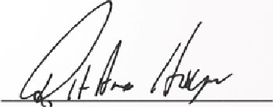

|  |  |  |
| --- | --- | --- |
|  |  |  |
|  | Tasmin Lucia-Khan  Board Member | |

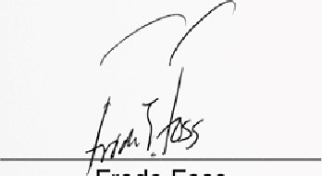Frode Foss Rolf Arne Høyen 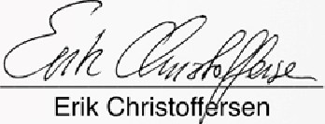Erik Christoff sen ChairmanBoard Member General Manager



17

